DBMS

Remaining topics

1. <https://www.sanfoundry.com/1000-database-management-system-questions-answers/#dbms-chapters>

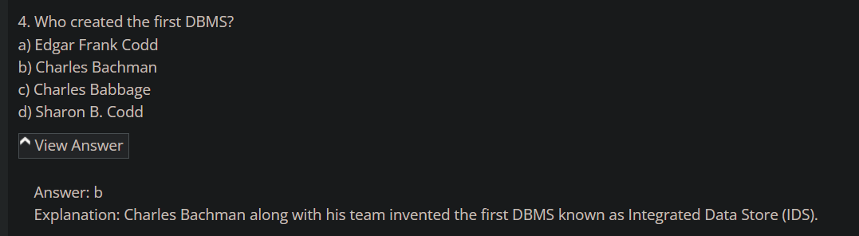

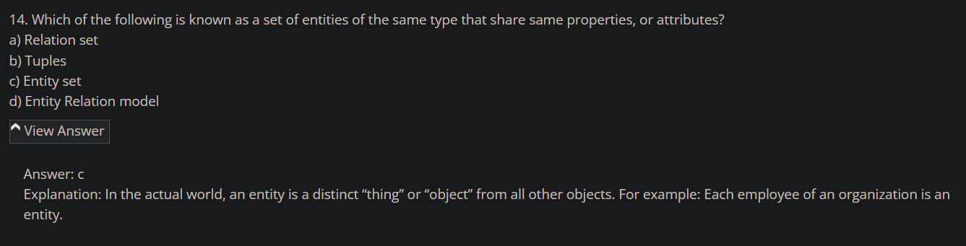

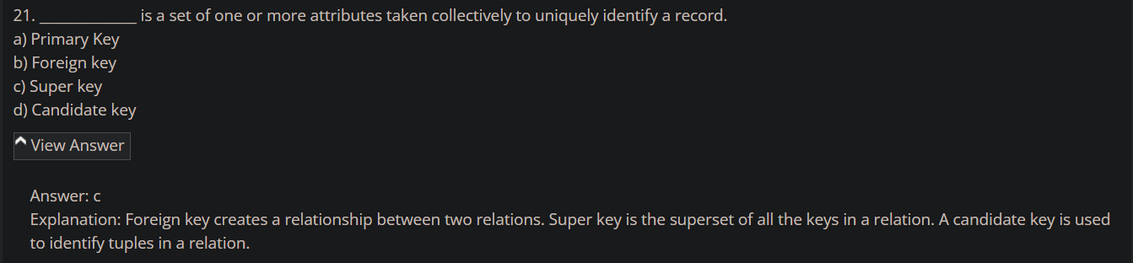

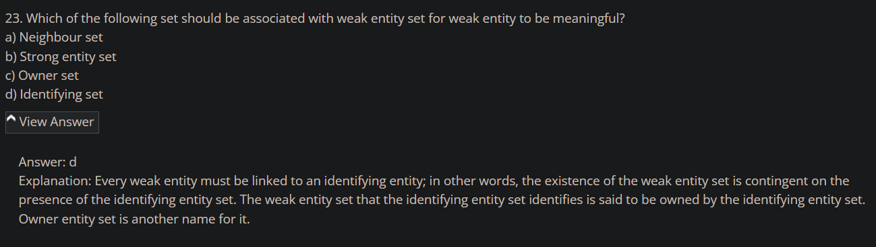

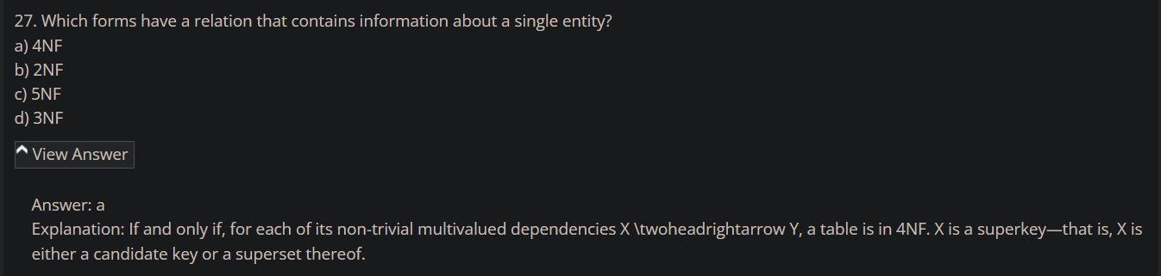

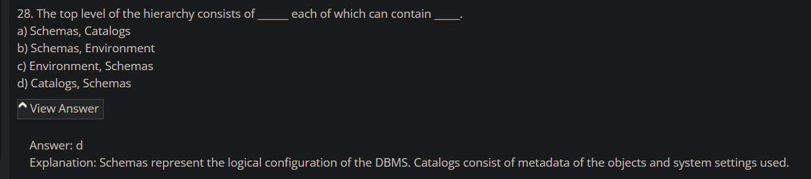

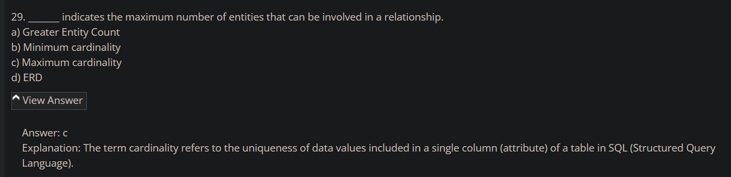

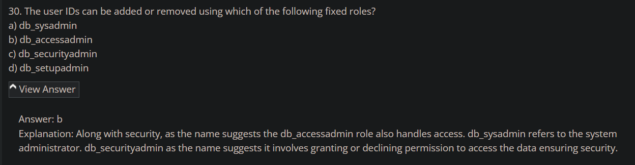

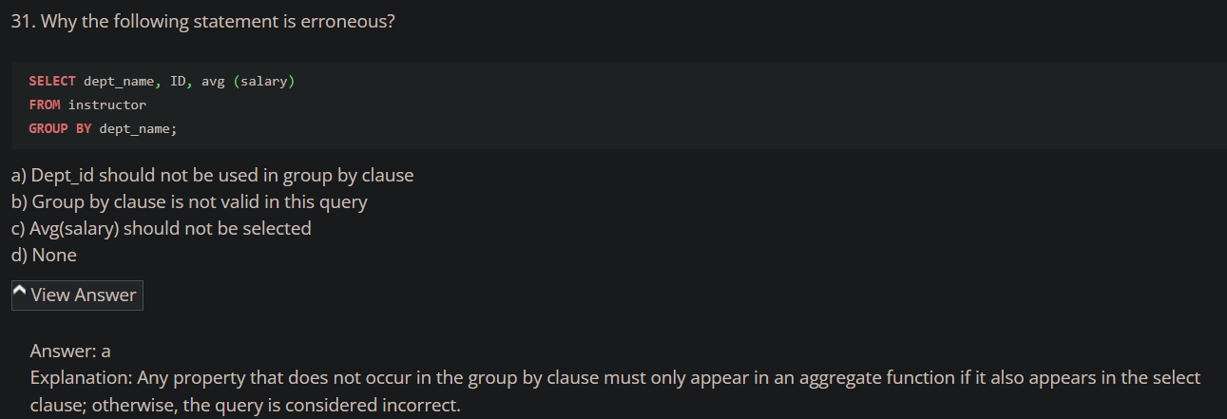

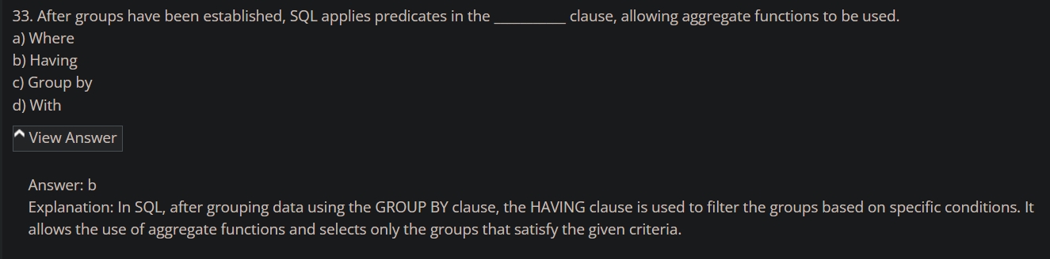

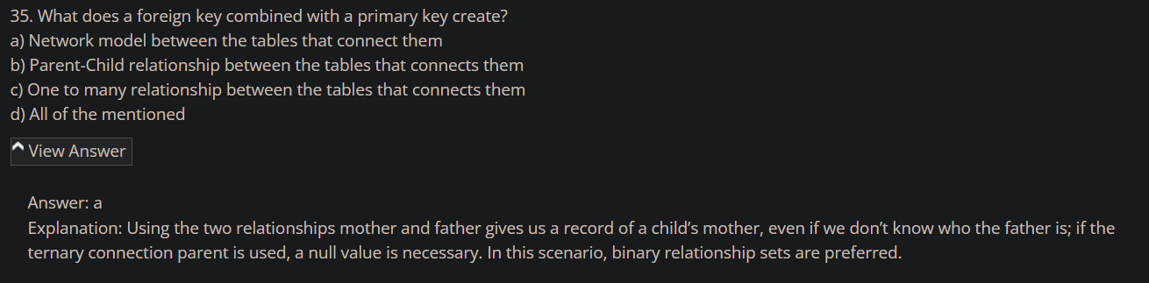

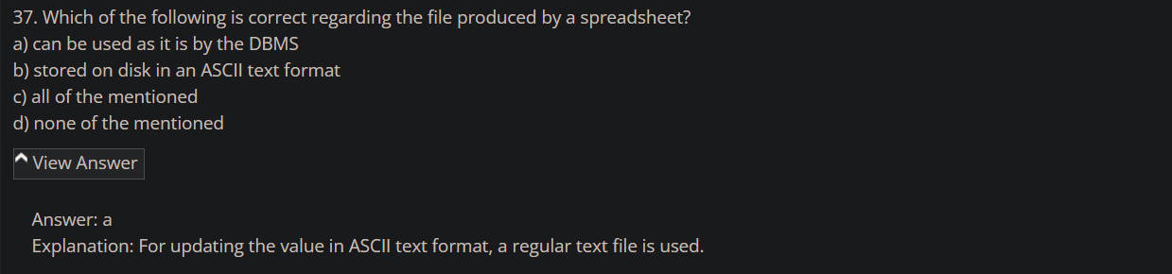

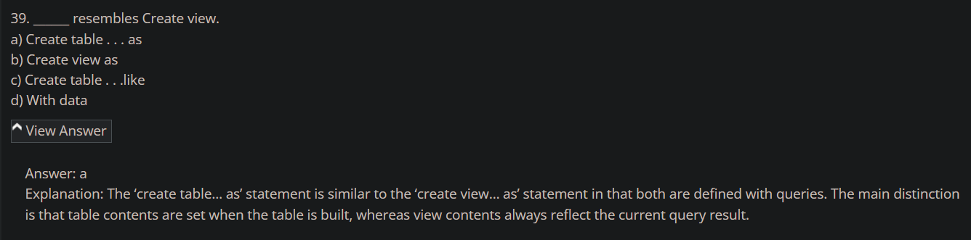

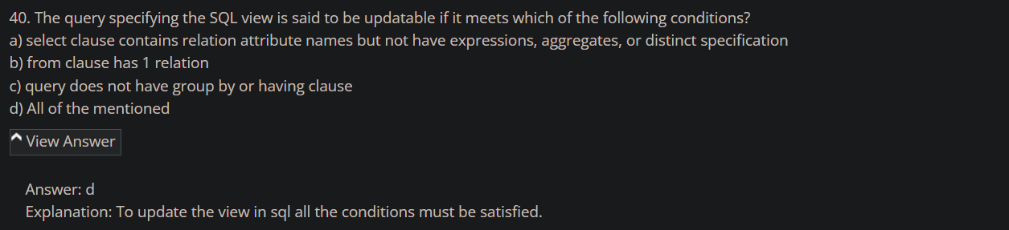

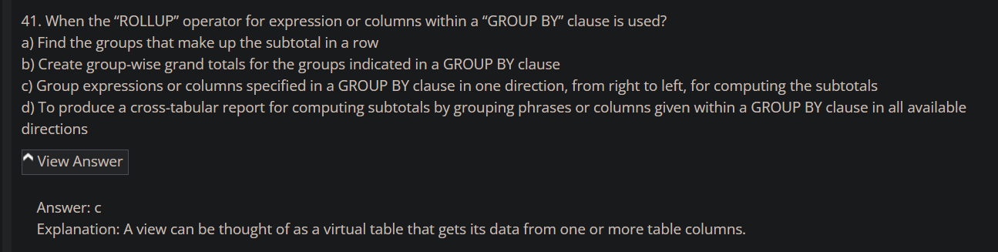

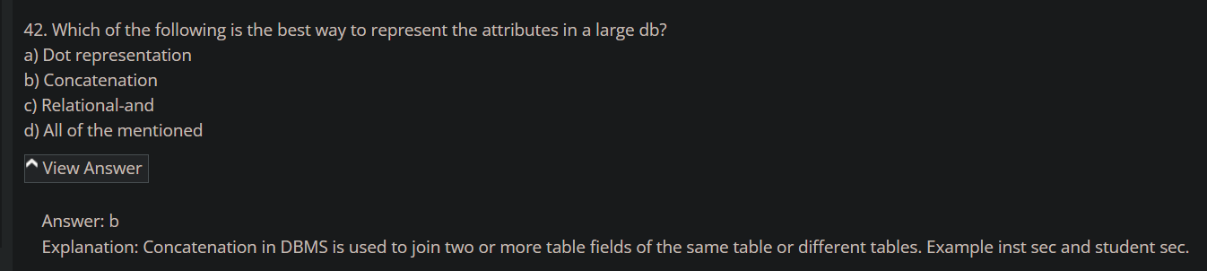

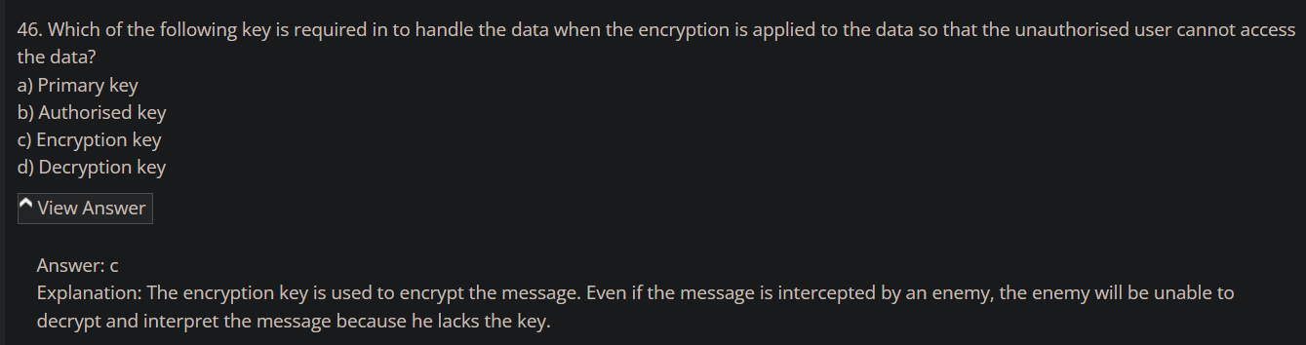

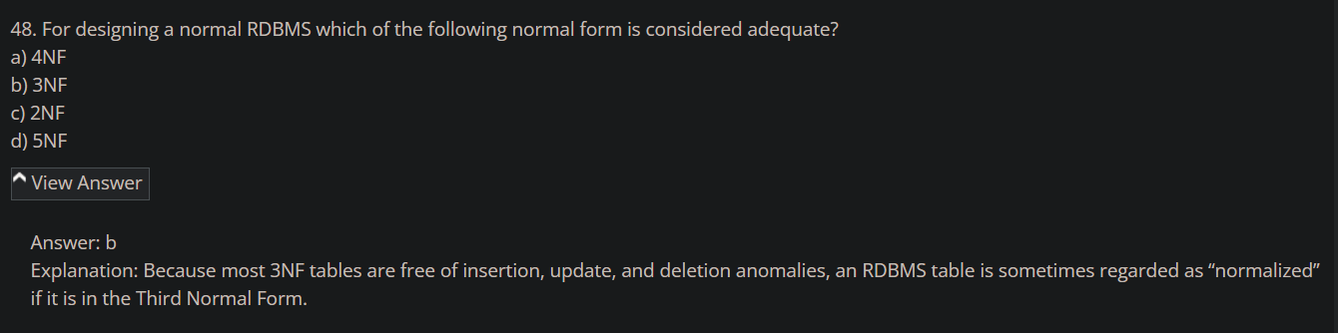

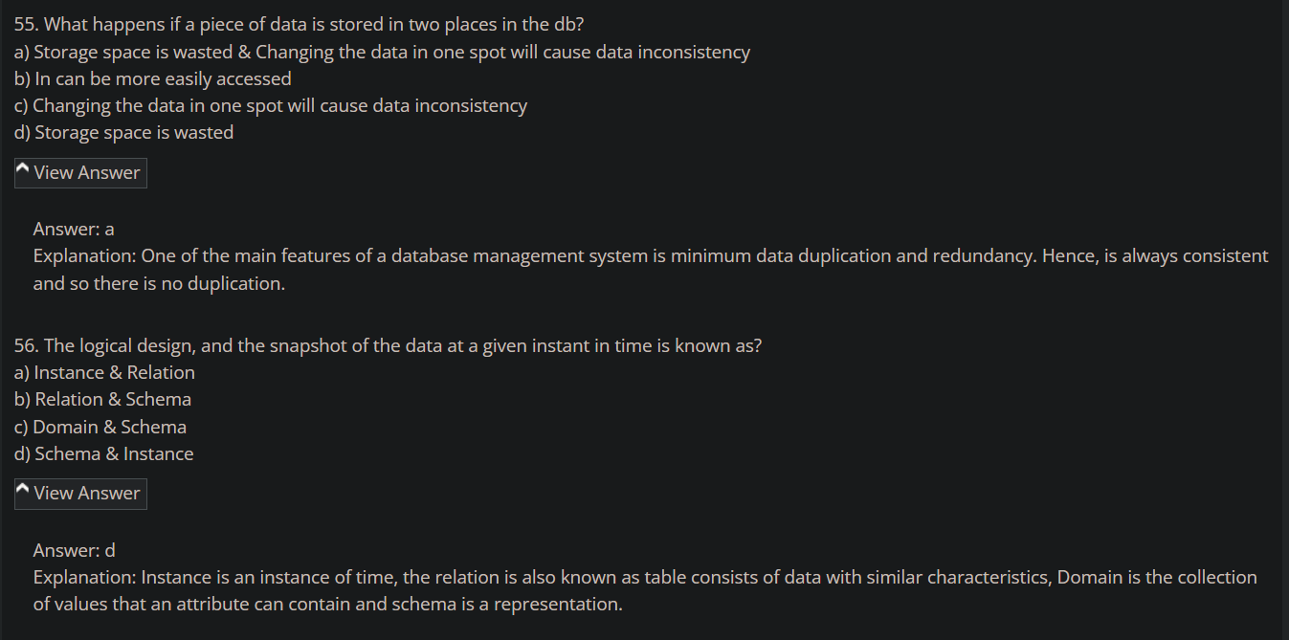

1. <https://www.sanfoundry.com/database-mcqs-relational-database-schema/>

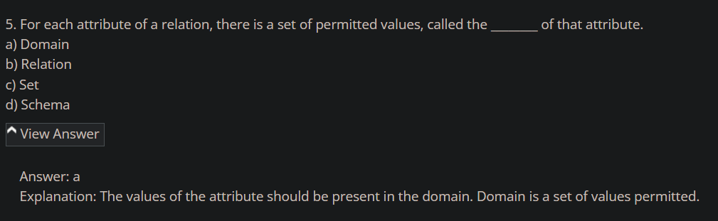

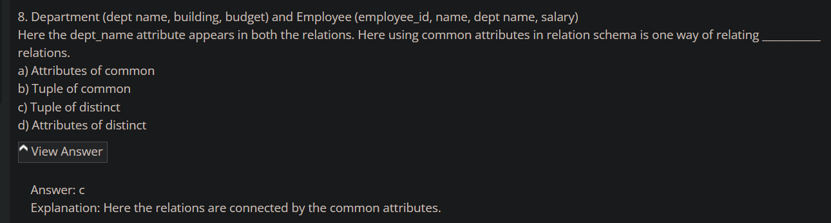

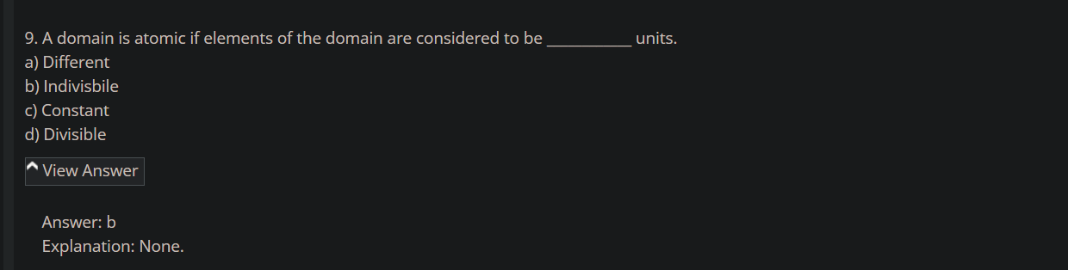

1. <https://www.sanfoundry.com/database-mcqs-keys/>

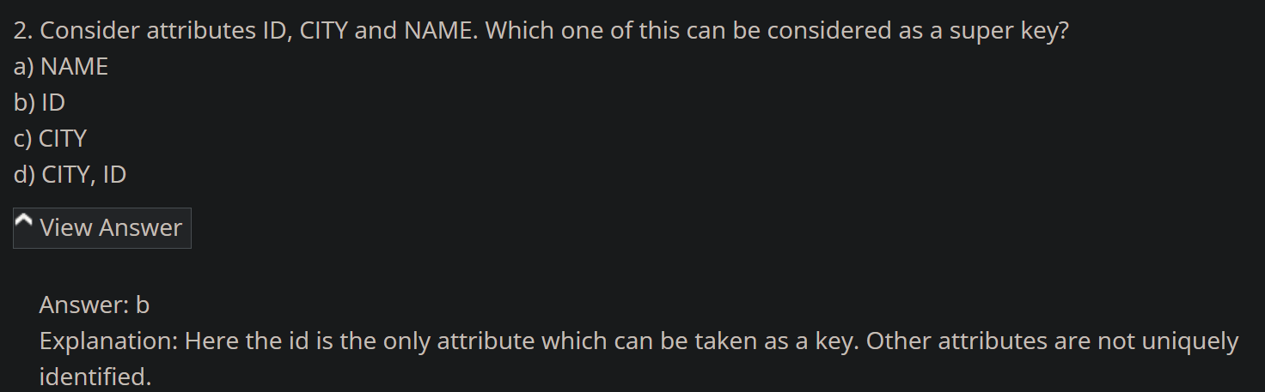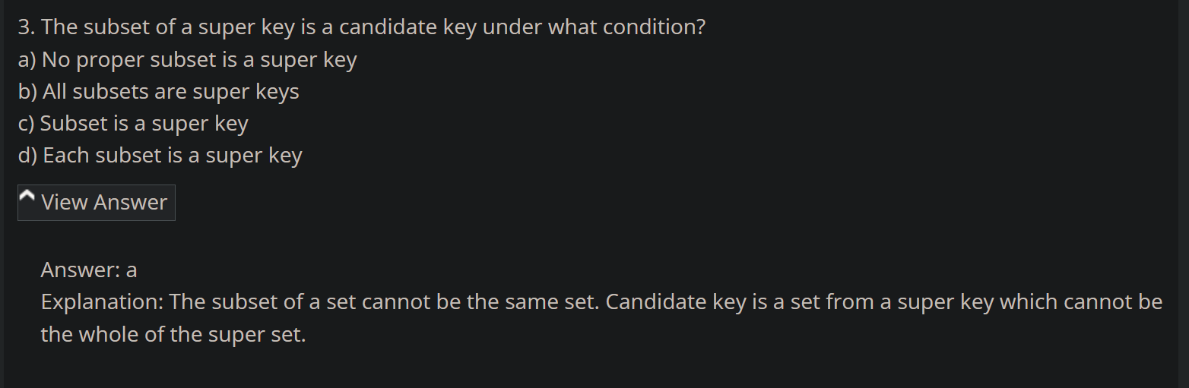

Relation =~= Table

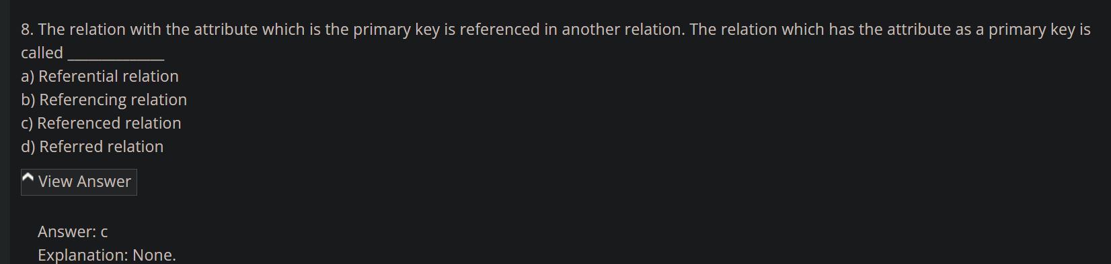

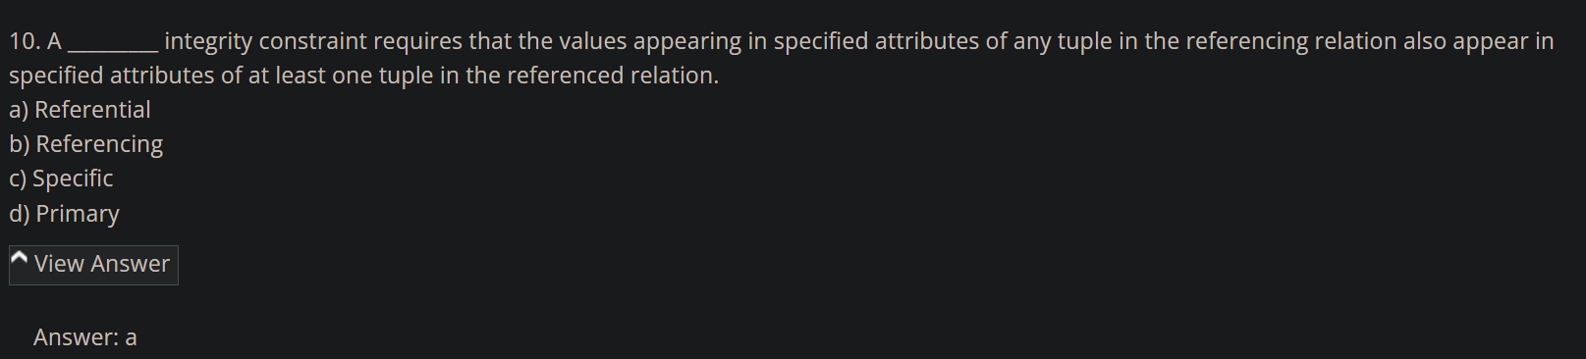

1. https://www.sanfoundry.com/database-questions-answers-mcqs/

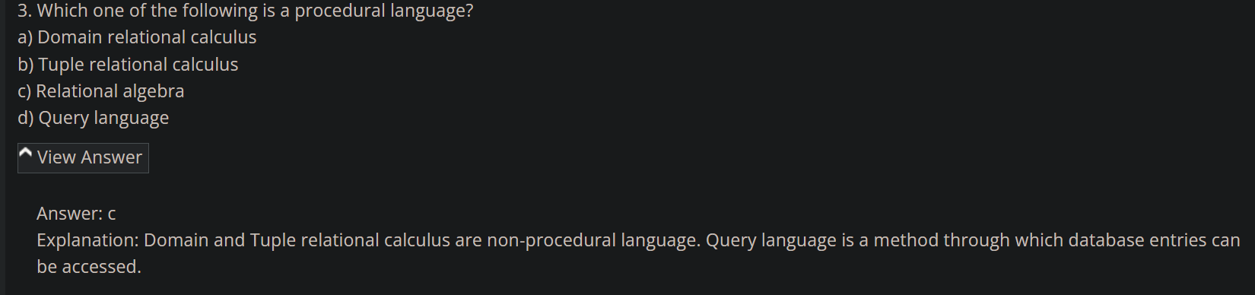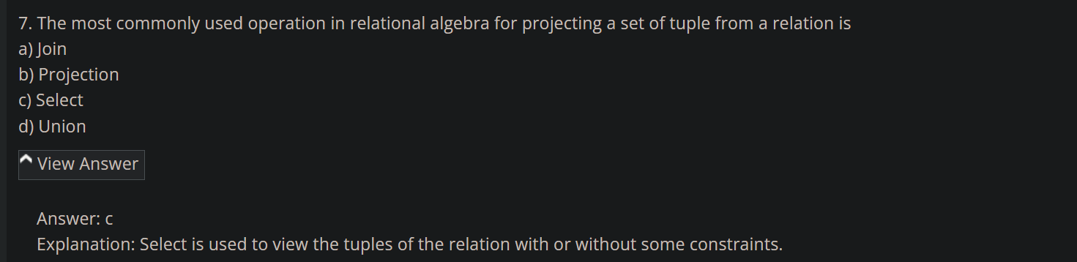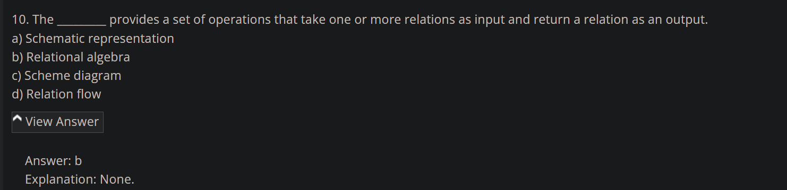

1. <https://www.sanfoundry.com/database-mcqs-sql-basics-definitions/>

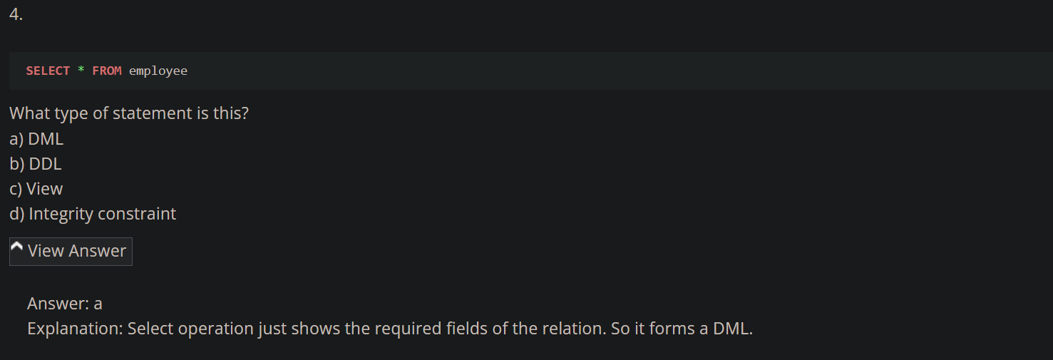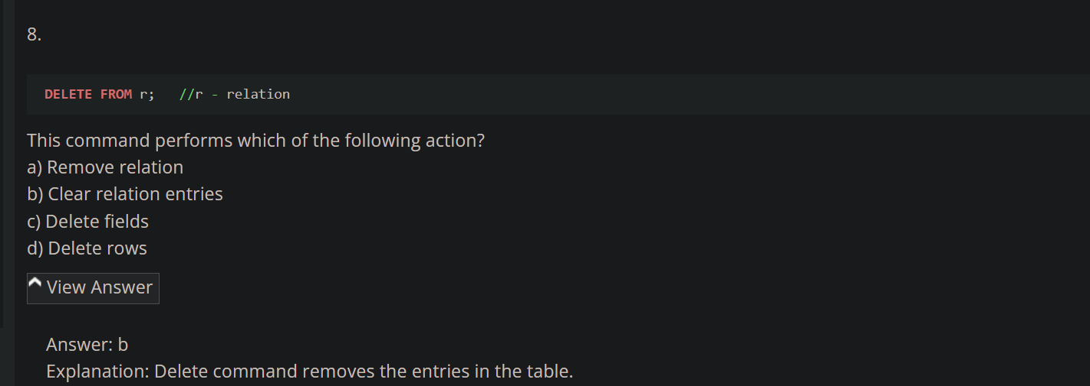

1. <https://www.sanfoundry.com/rdbms-questions-answers-sql-data-definition/>

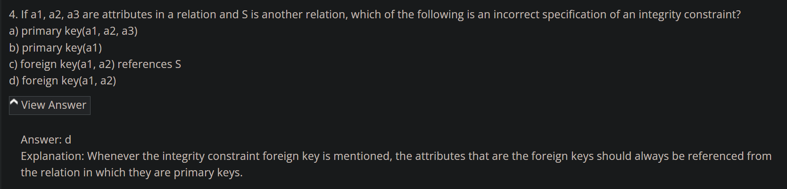

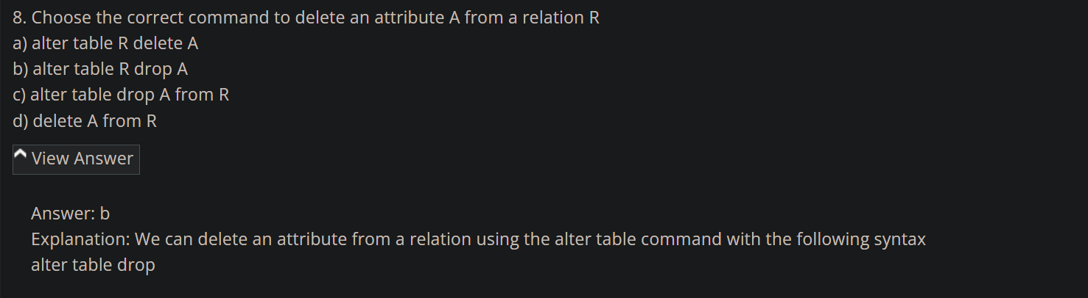

1. <https://www.interviewbit.com/rdbms-mcq/>

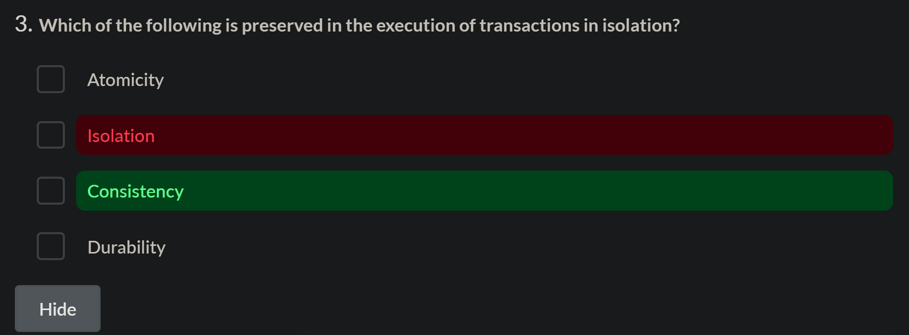

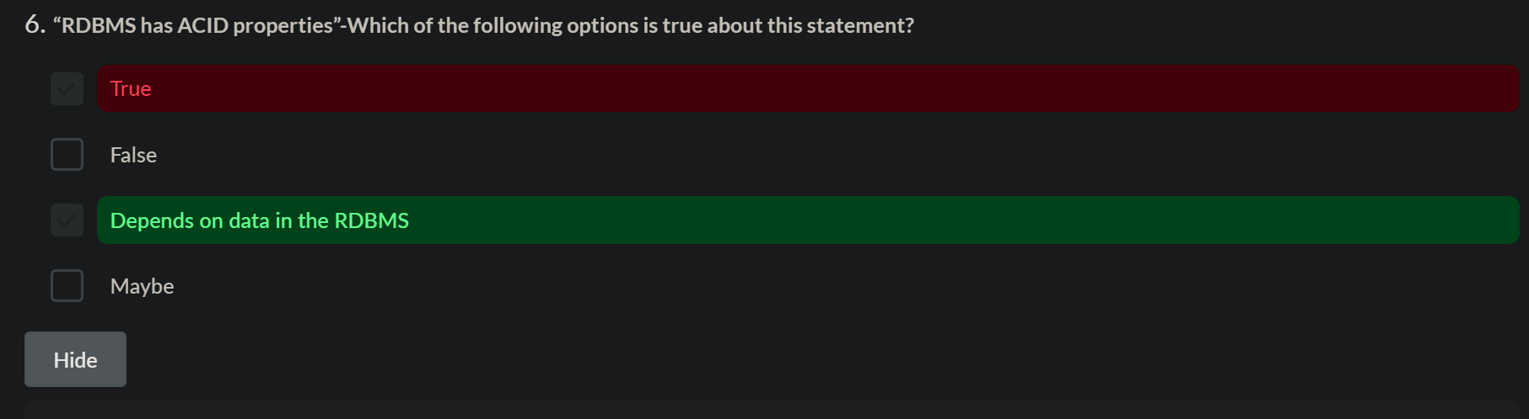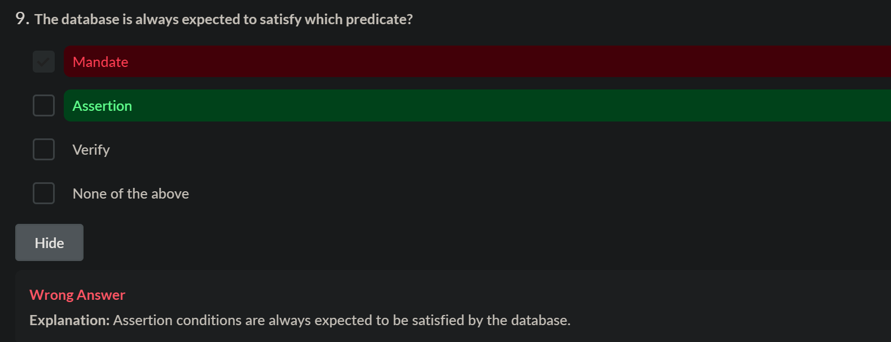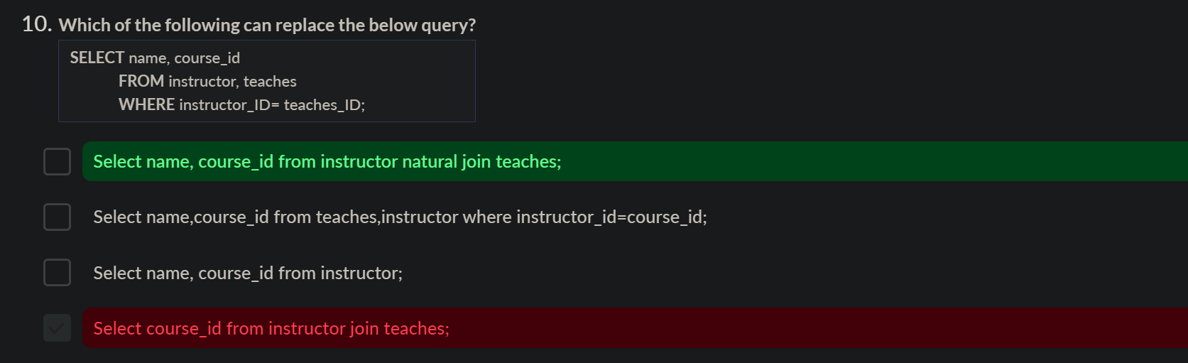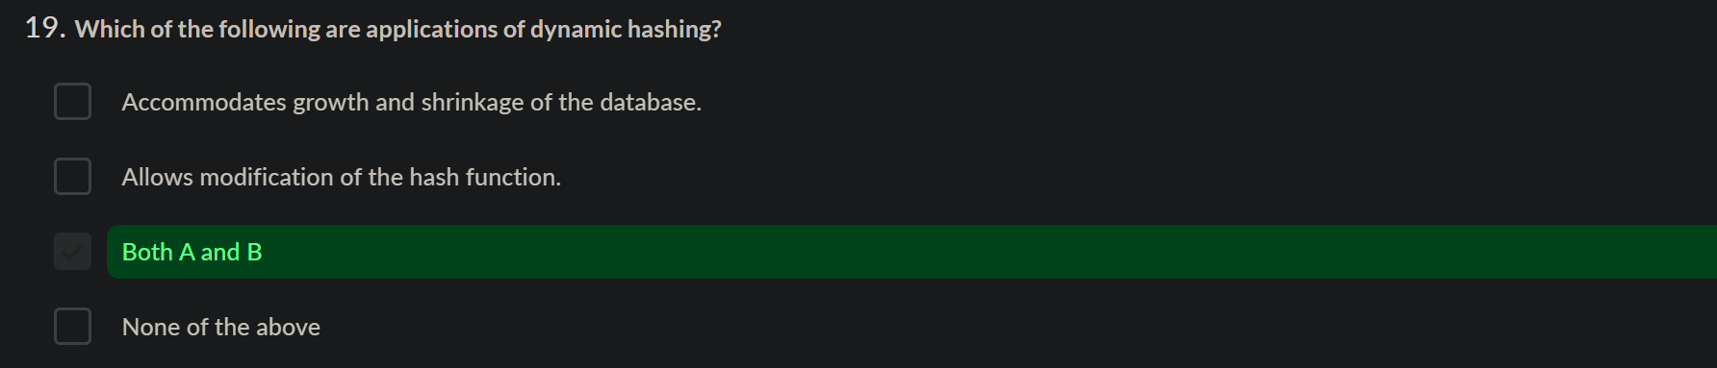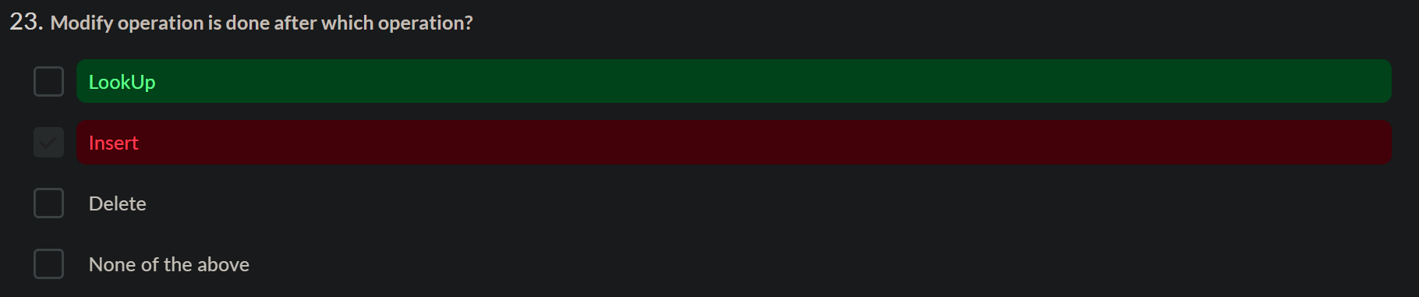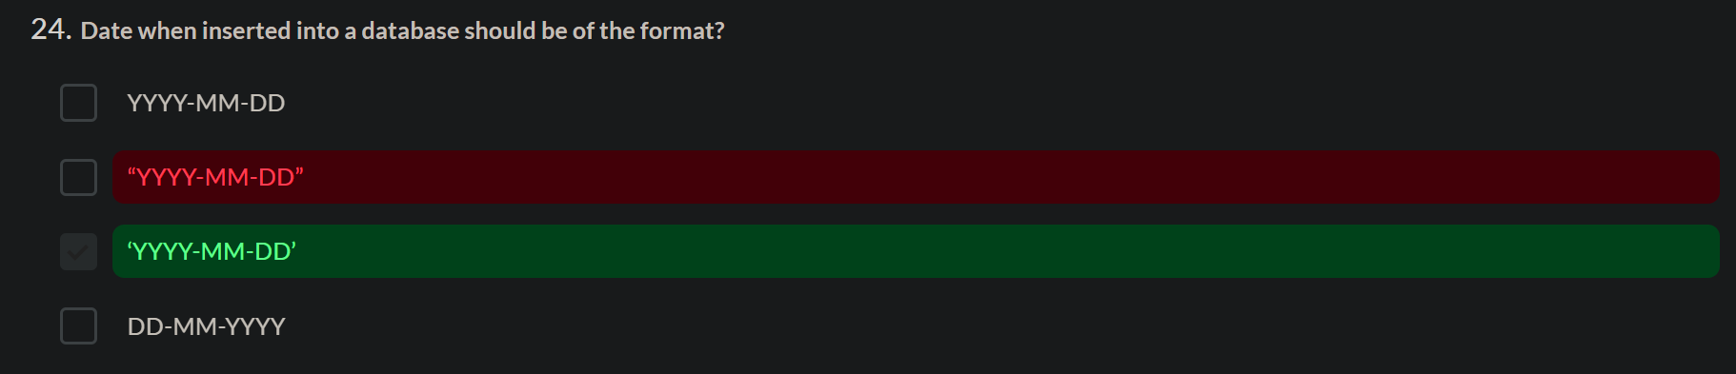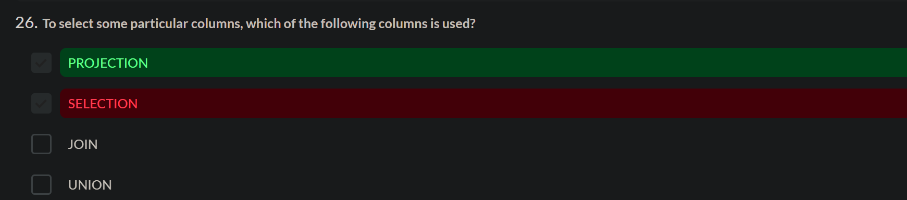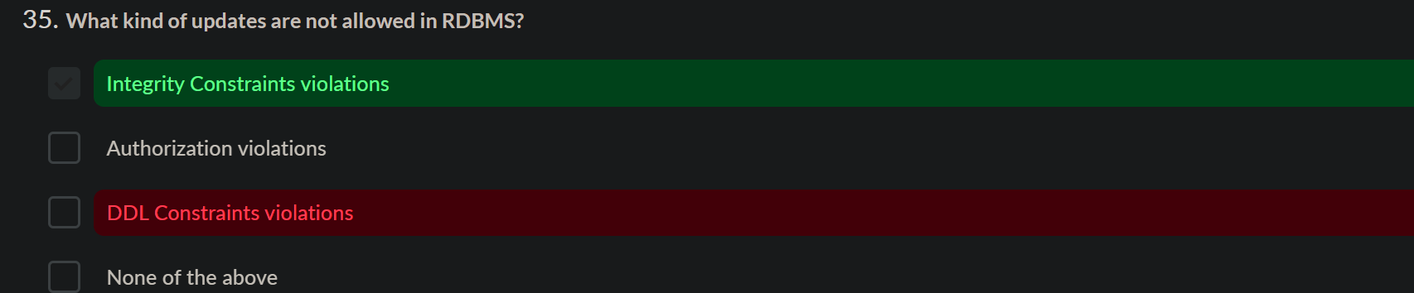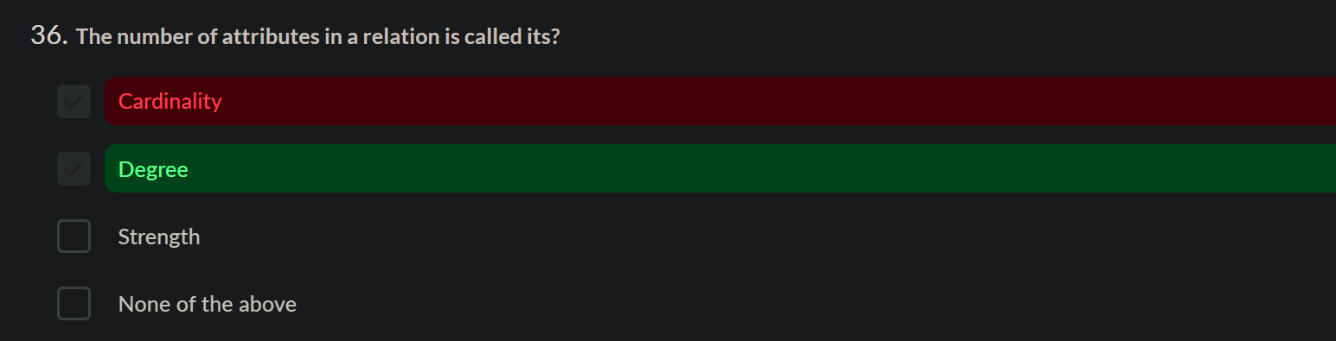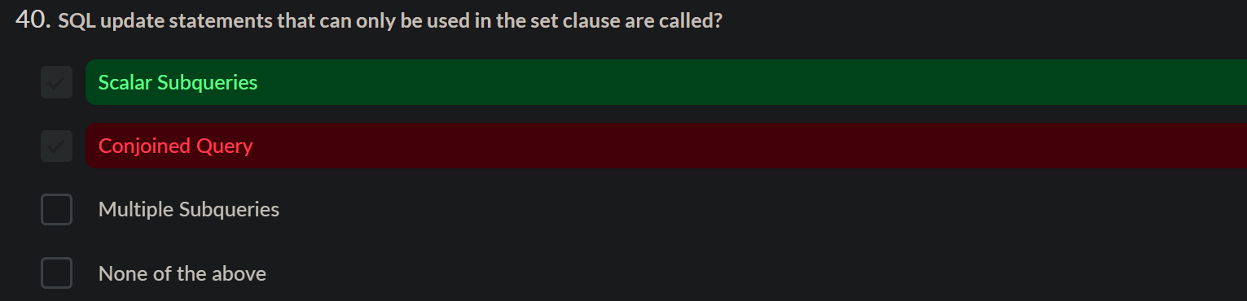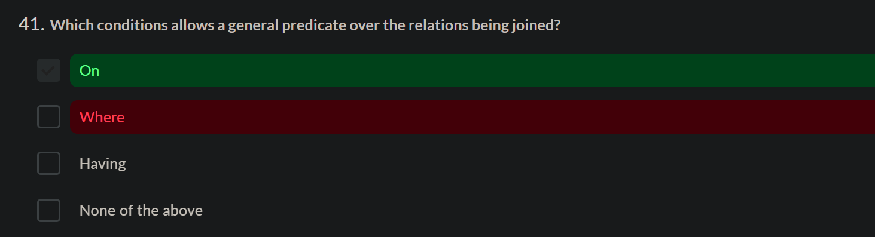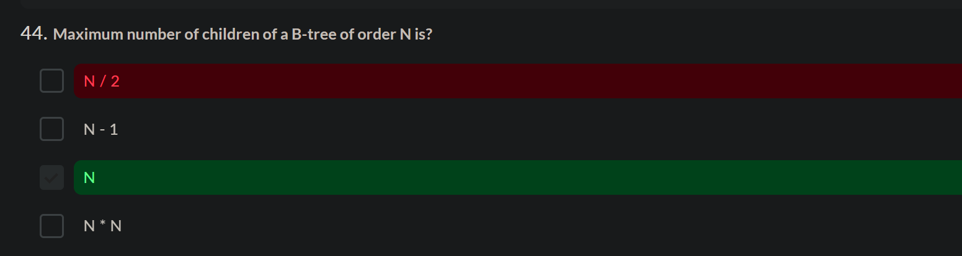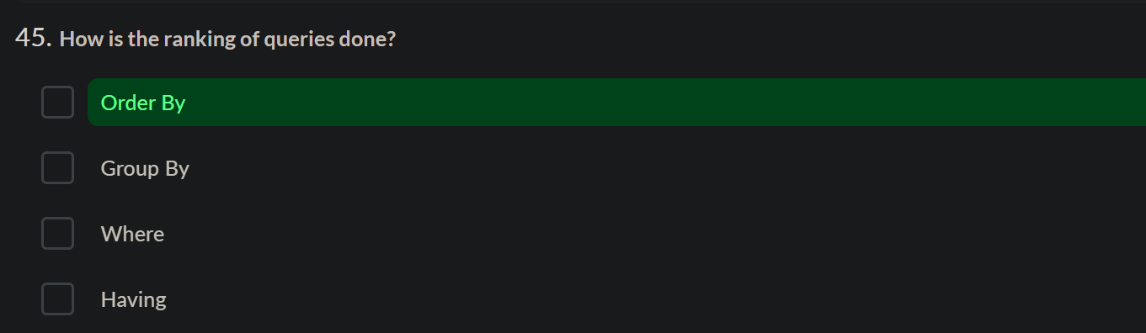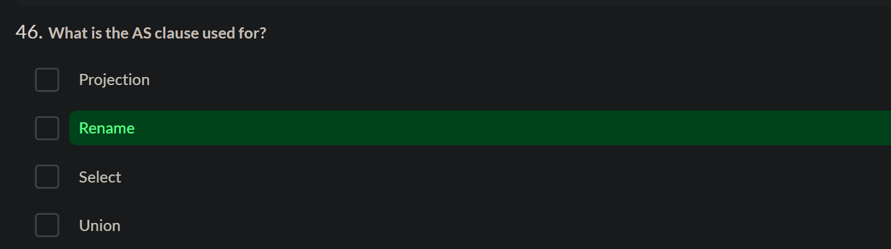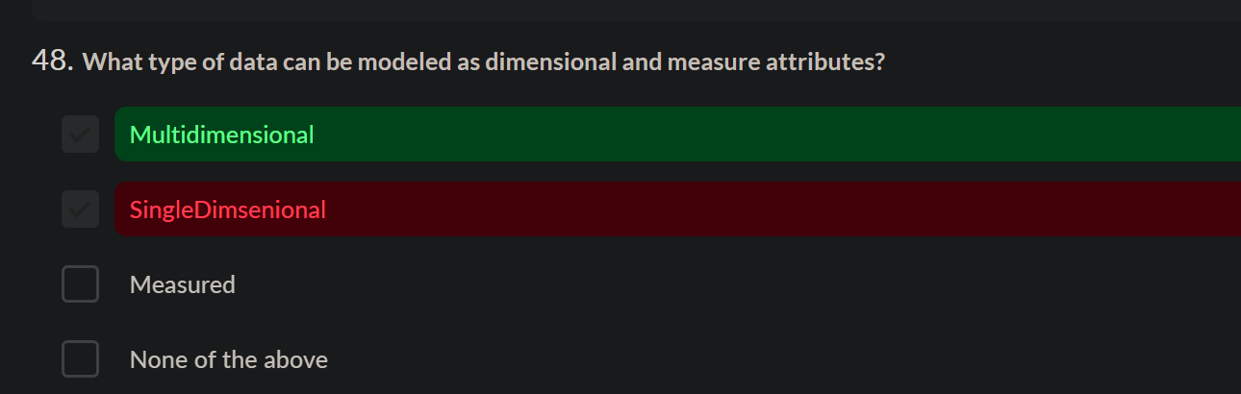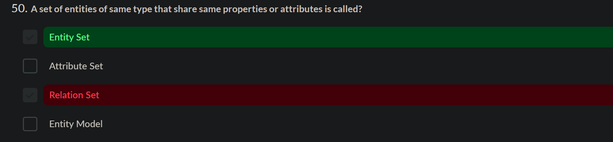

To calculate date of birth

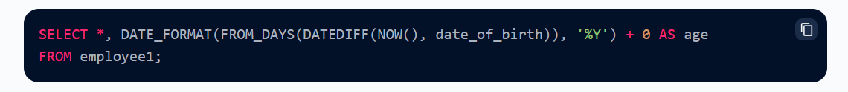

**1-1-2024**

1. <https://www.sanfoundry.com/rdbms-questions-answers-introduction-relational-model/>

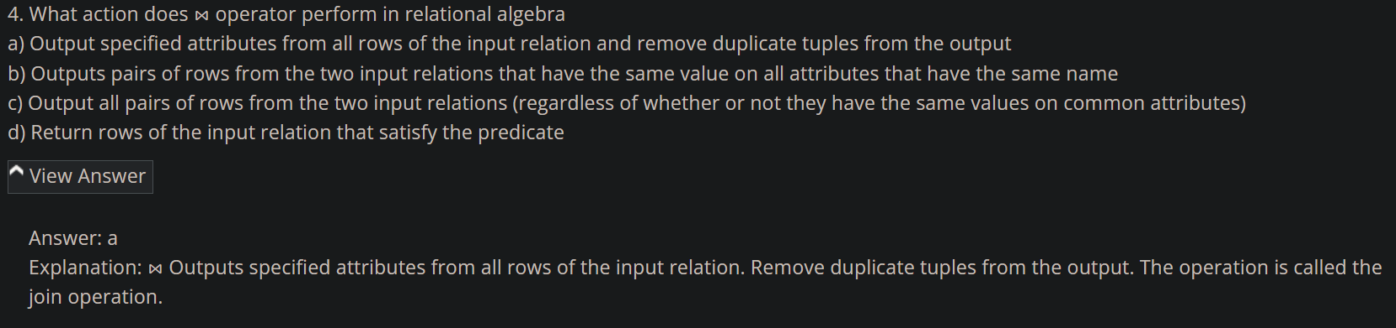

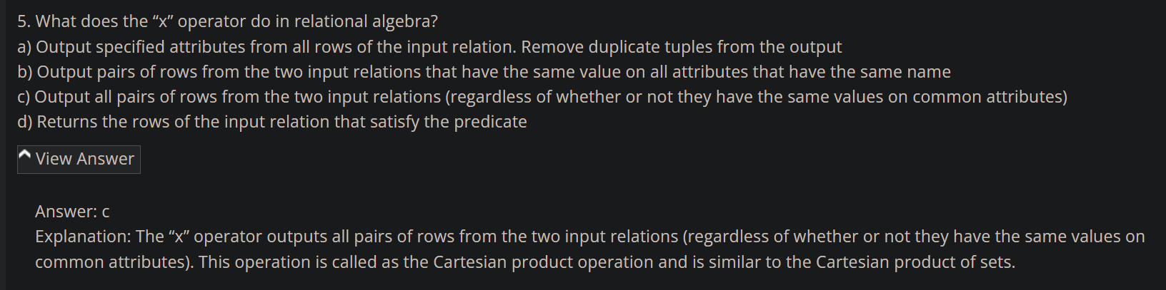

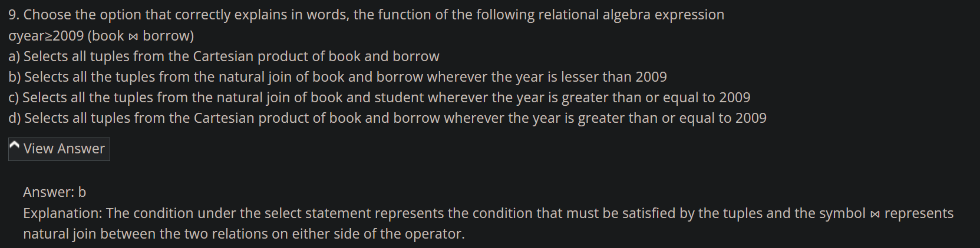

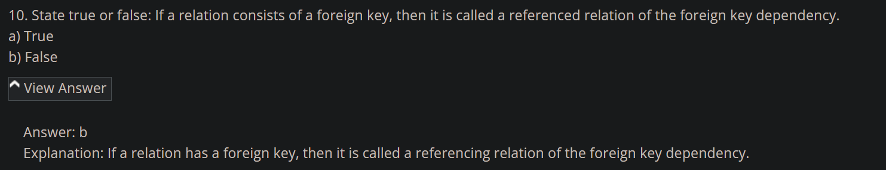

1. <https://www.sanfoundry.com/rdbms-questions-answers-basic-operations/>

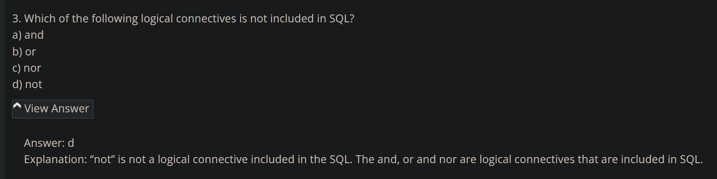

1. <https://www.sanfoundry.com/rdbms-questions-answers-set-operations/>

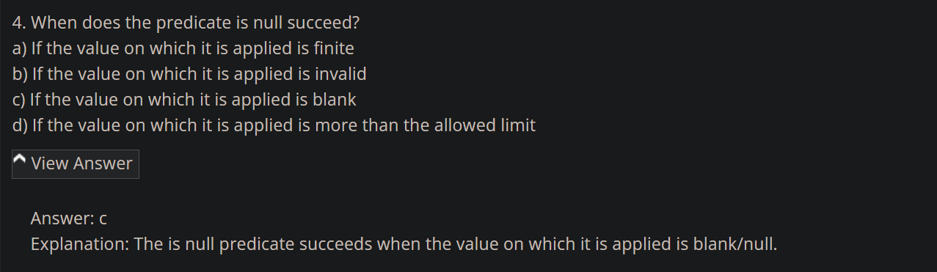

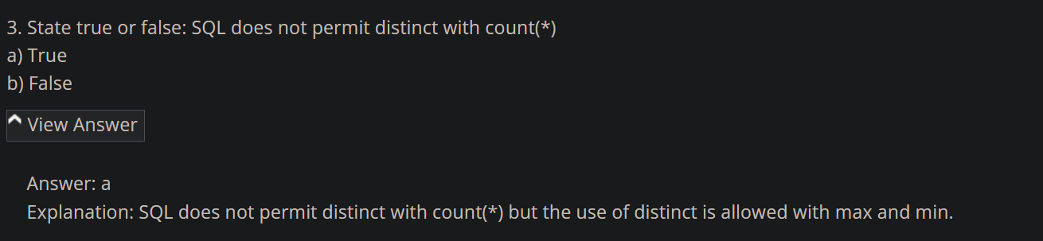

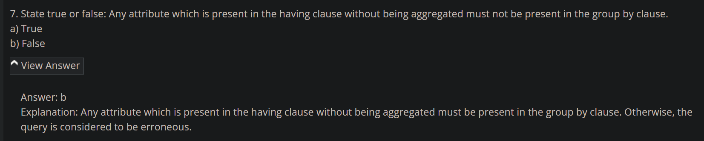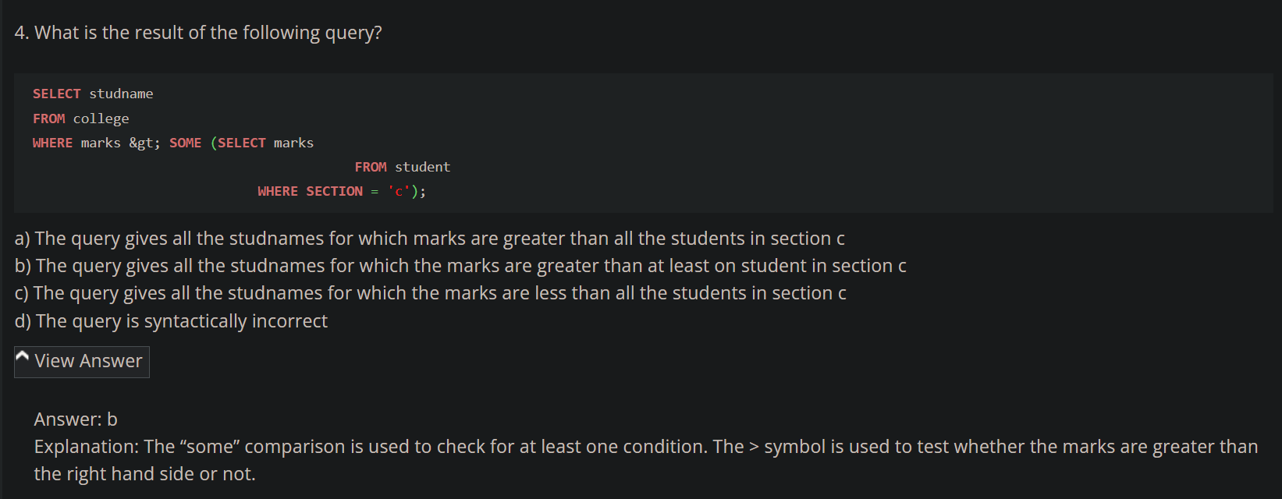

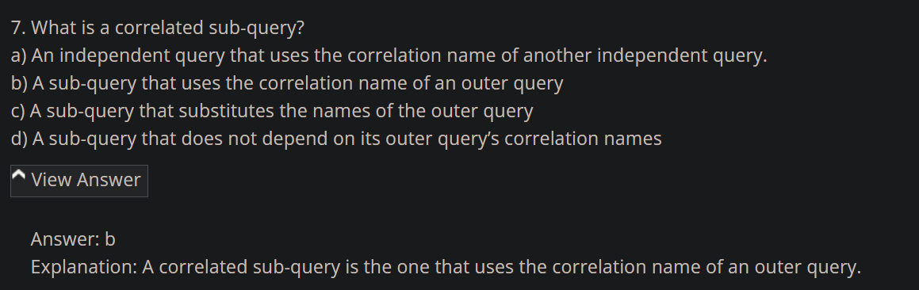

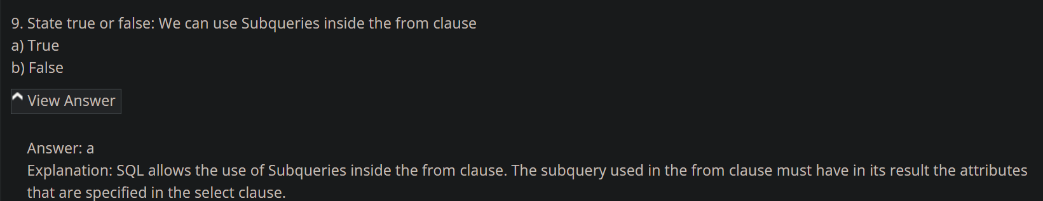

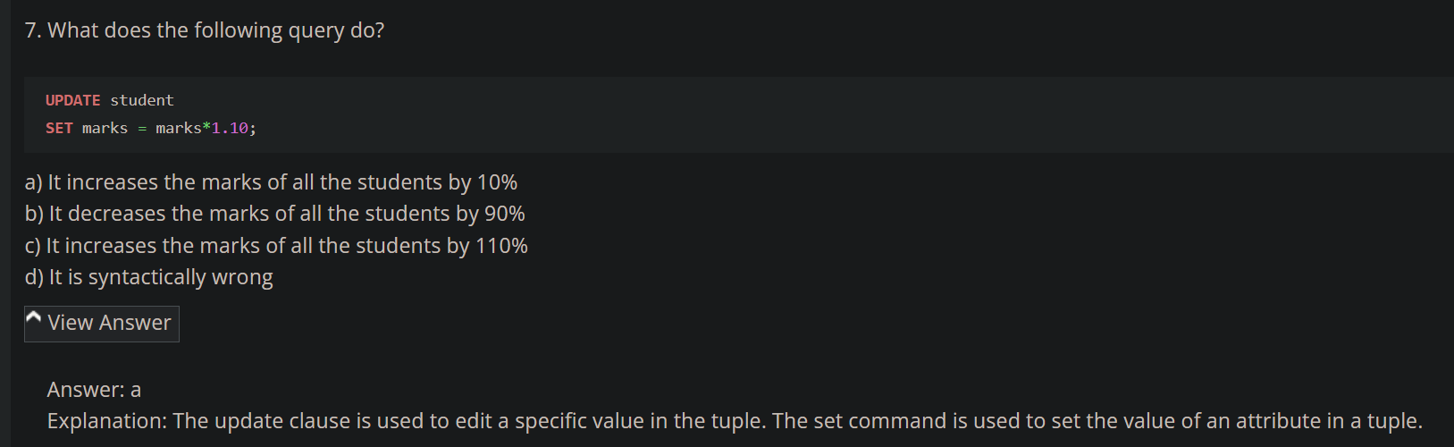

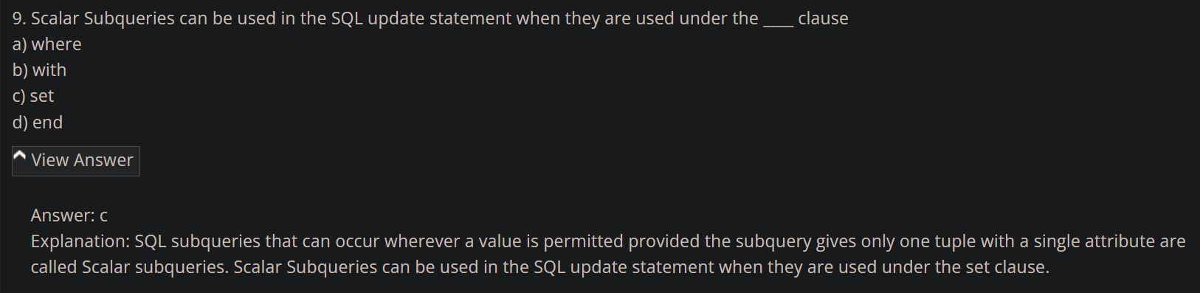

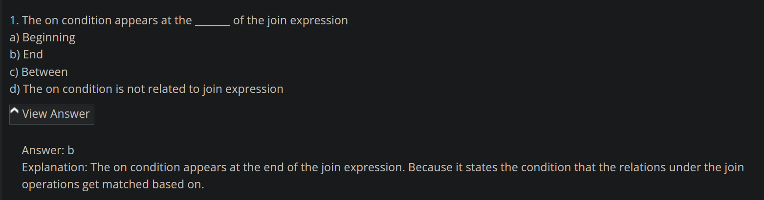

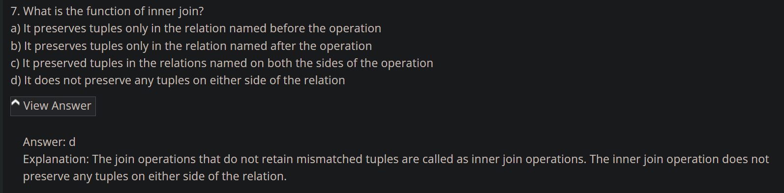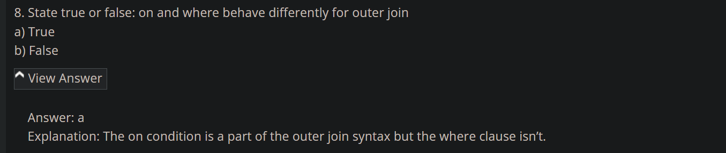

<https://www.sanfoundry.com/rdbms-questions-answers-views-transactions/>



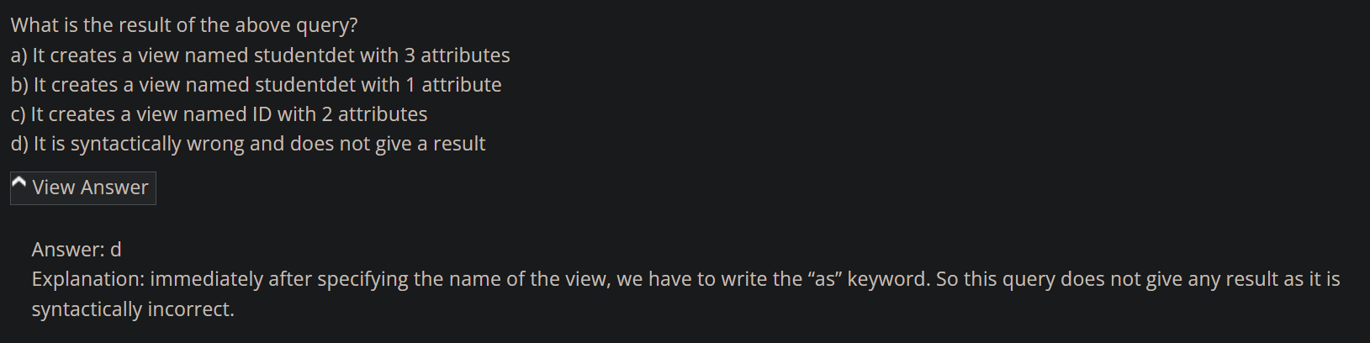

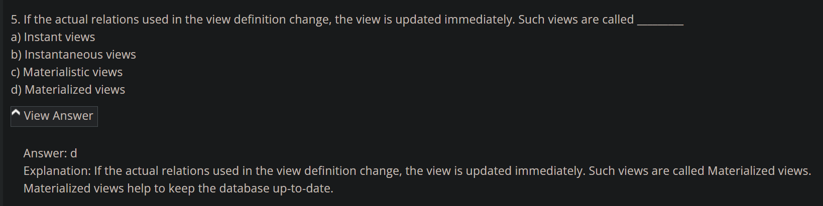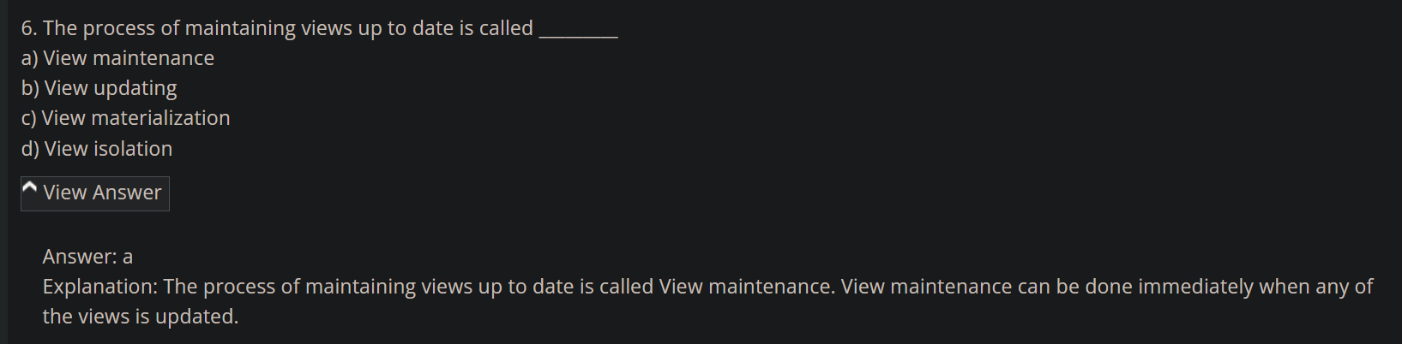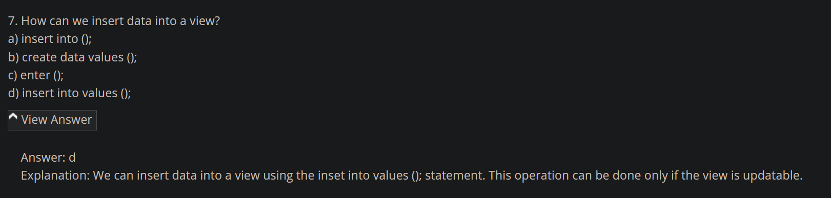

<https://www.sanfoundry.com/rdbms-questions-answers-integrity-constraints/>

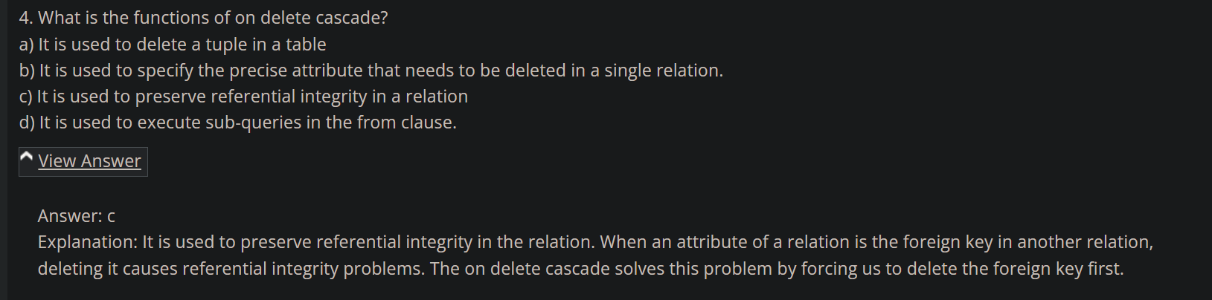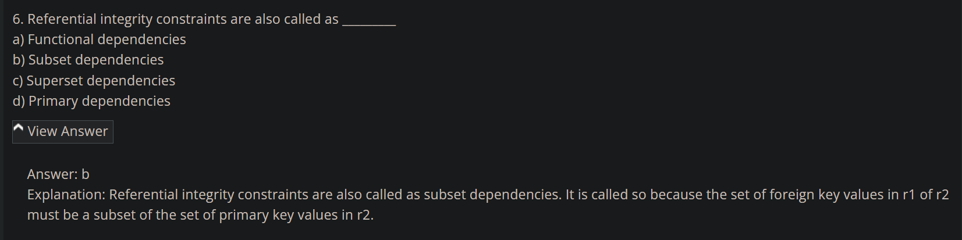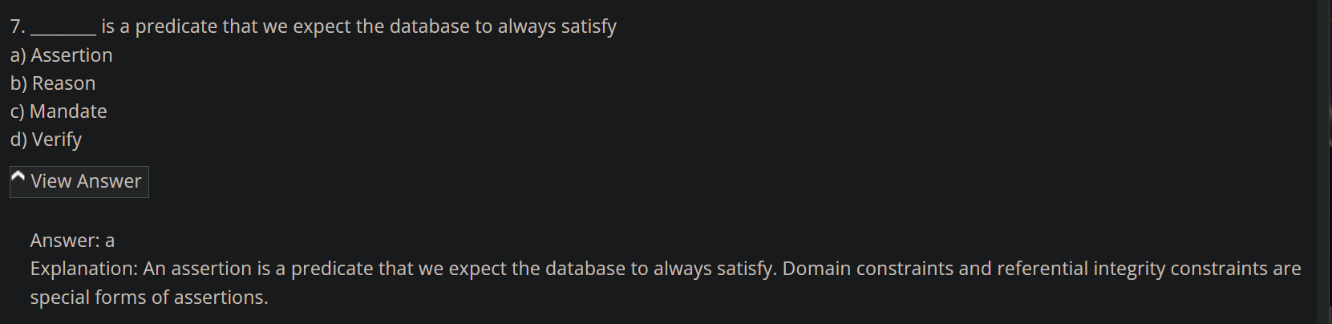

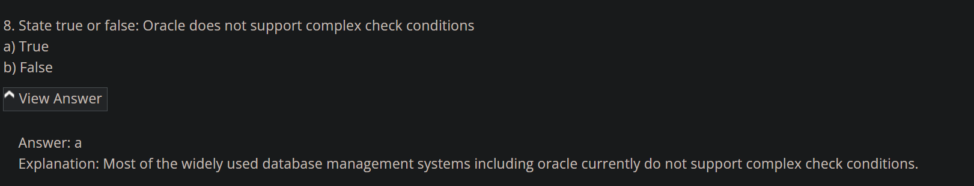

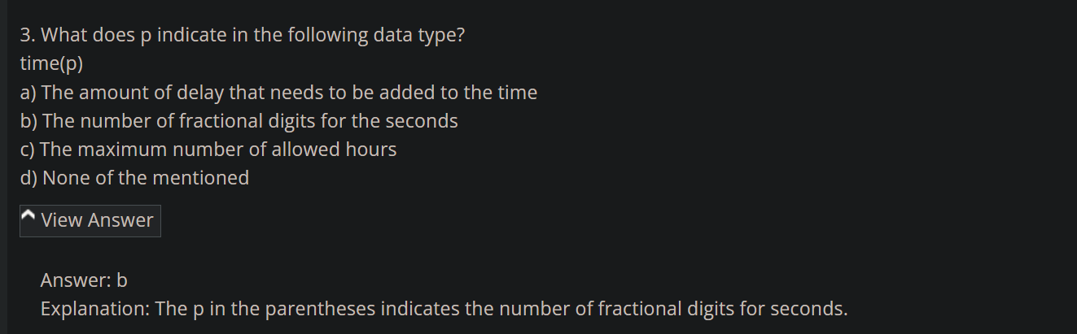

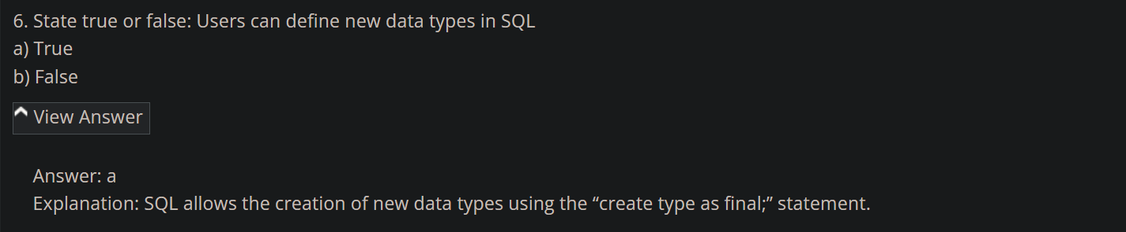

<https://www.sanfoundry.com/rdbms-interview-questions-answers-freshers/>

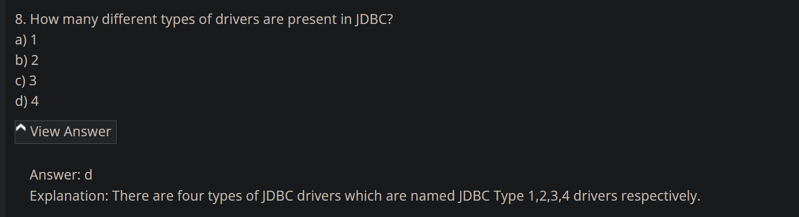

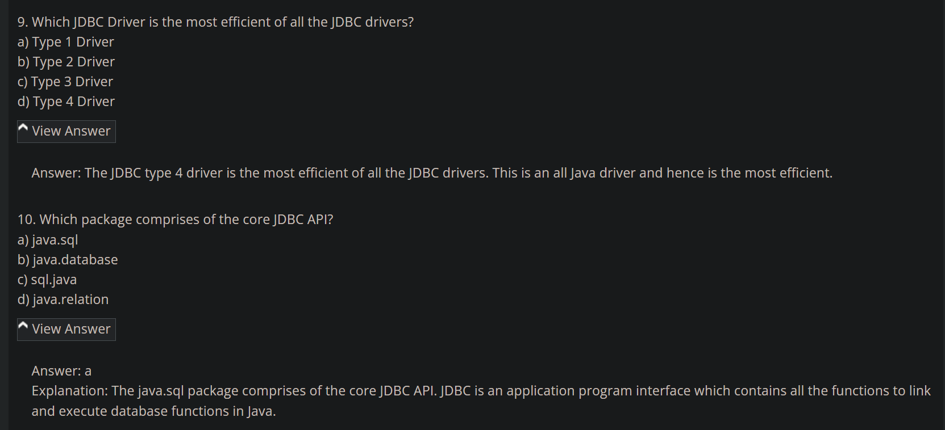

<https://www.sanfoundry.com/rdbms-questions-answers-experienced/>

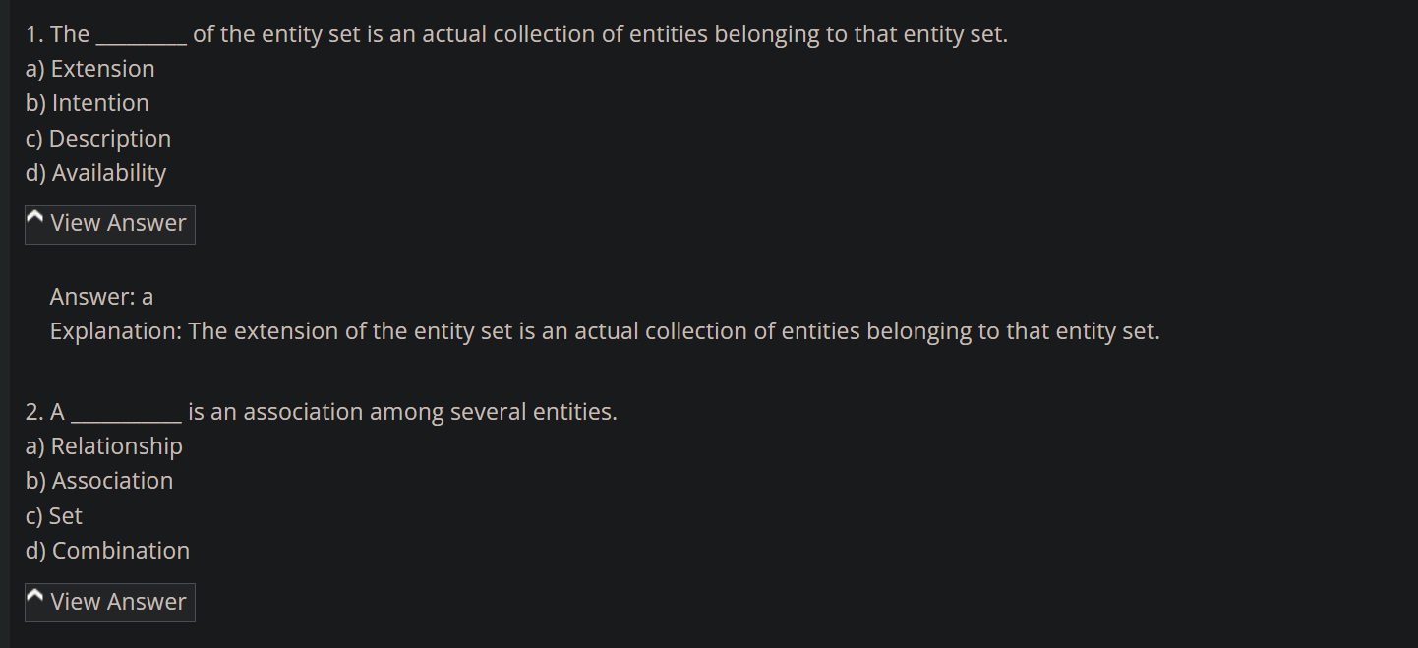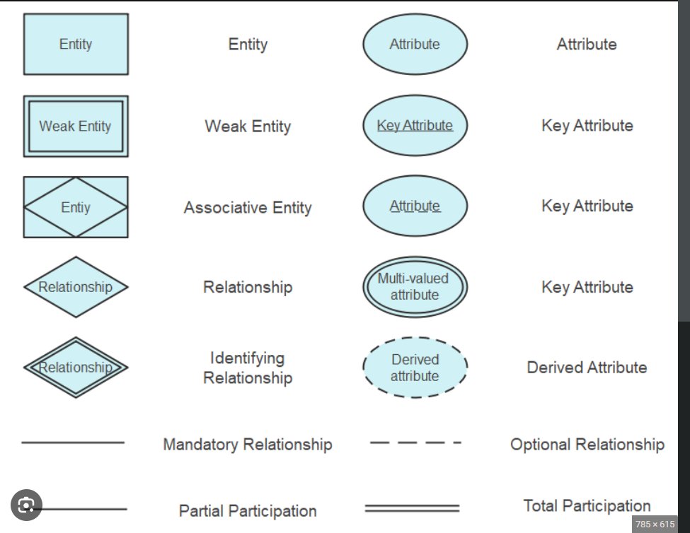

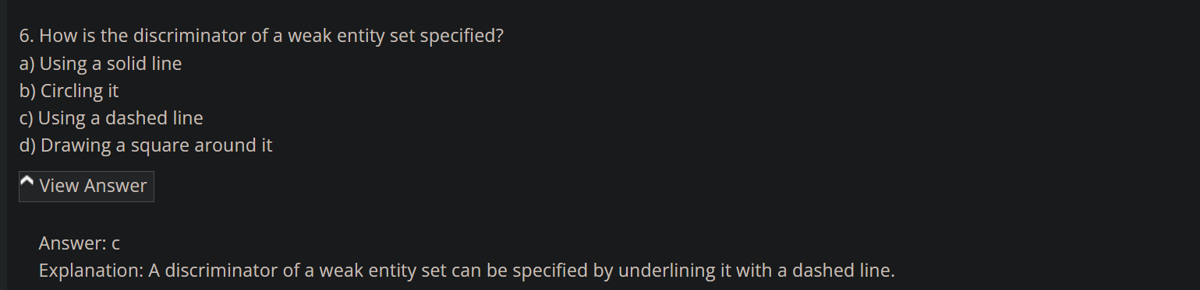

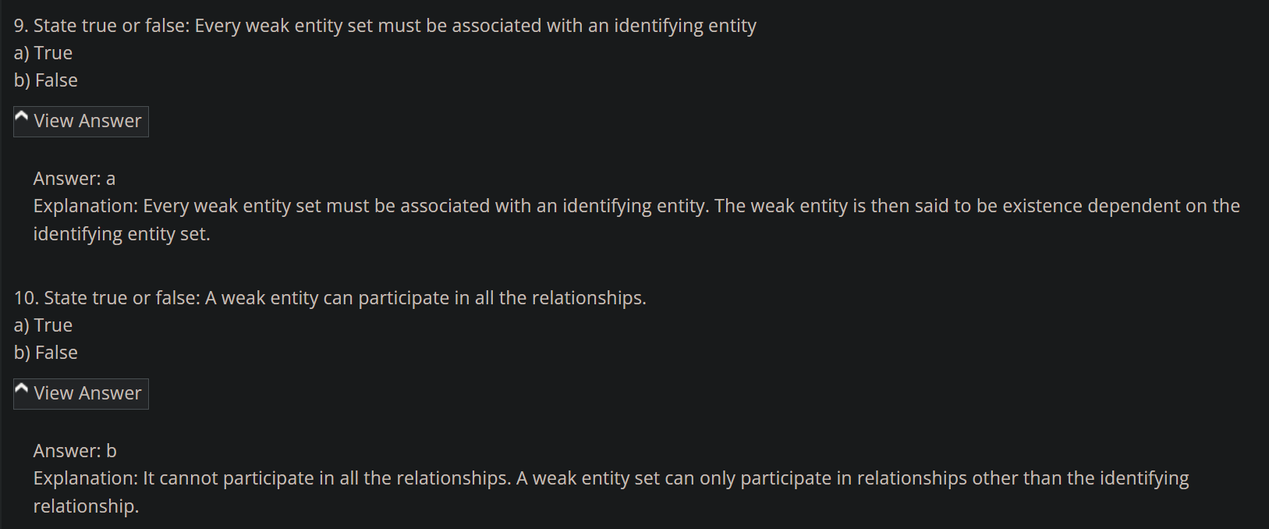

**MYSQL**

<https://www.sanfoundry.com/mysql-questions-answers-basic-database-terminology/>

<https://www.sanfoundry.com/mysql-questions-answers-interacting-mysql/>

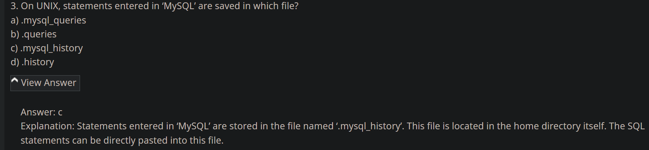

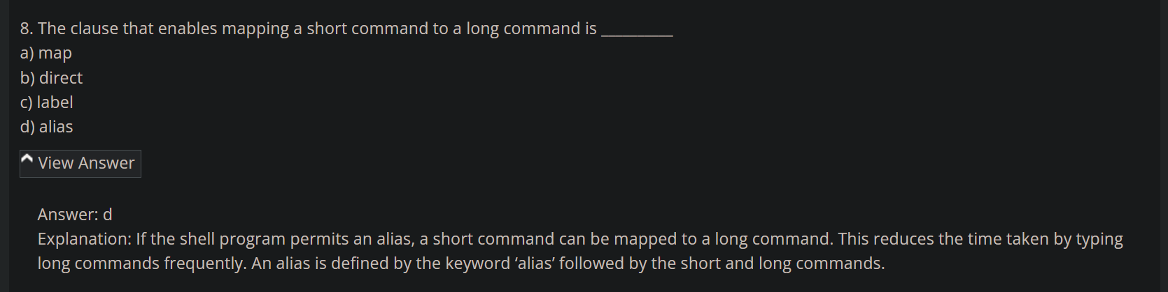

<https://www.sanfoundry.com/mysql-questions-answers-server-sql-mode/#google_vignette>

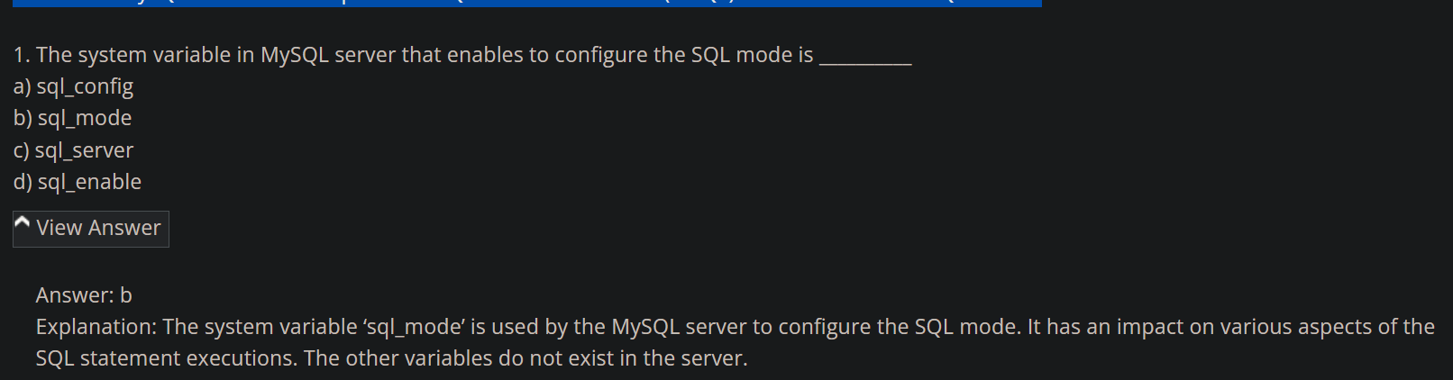

<https://www.sanfoundry.com/mysql-questions-answers-freshers/>

